**CAPM TASK**

1. **SCHEMA.CDS**

1. **Service. Cds**

1. **Service.js**

1. **Package.json**

1. **Xs-security.json**

1. **APPROUTER**

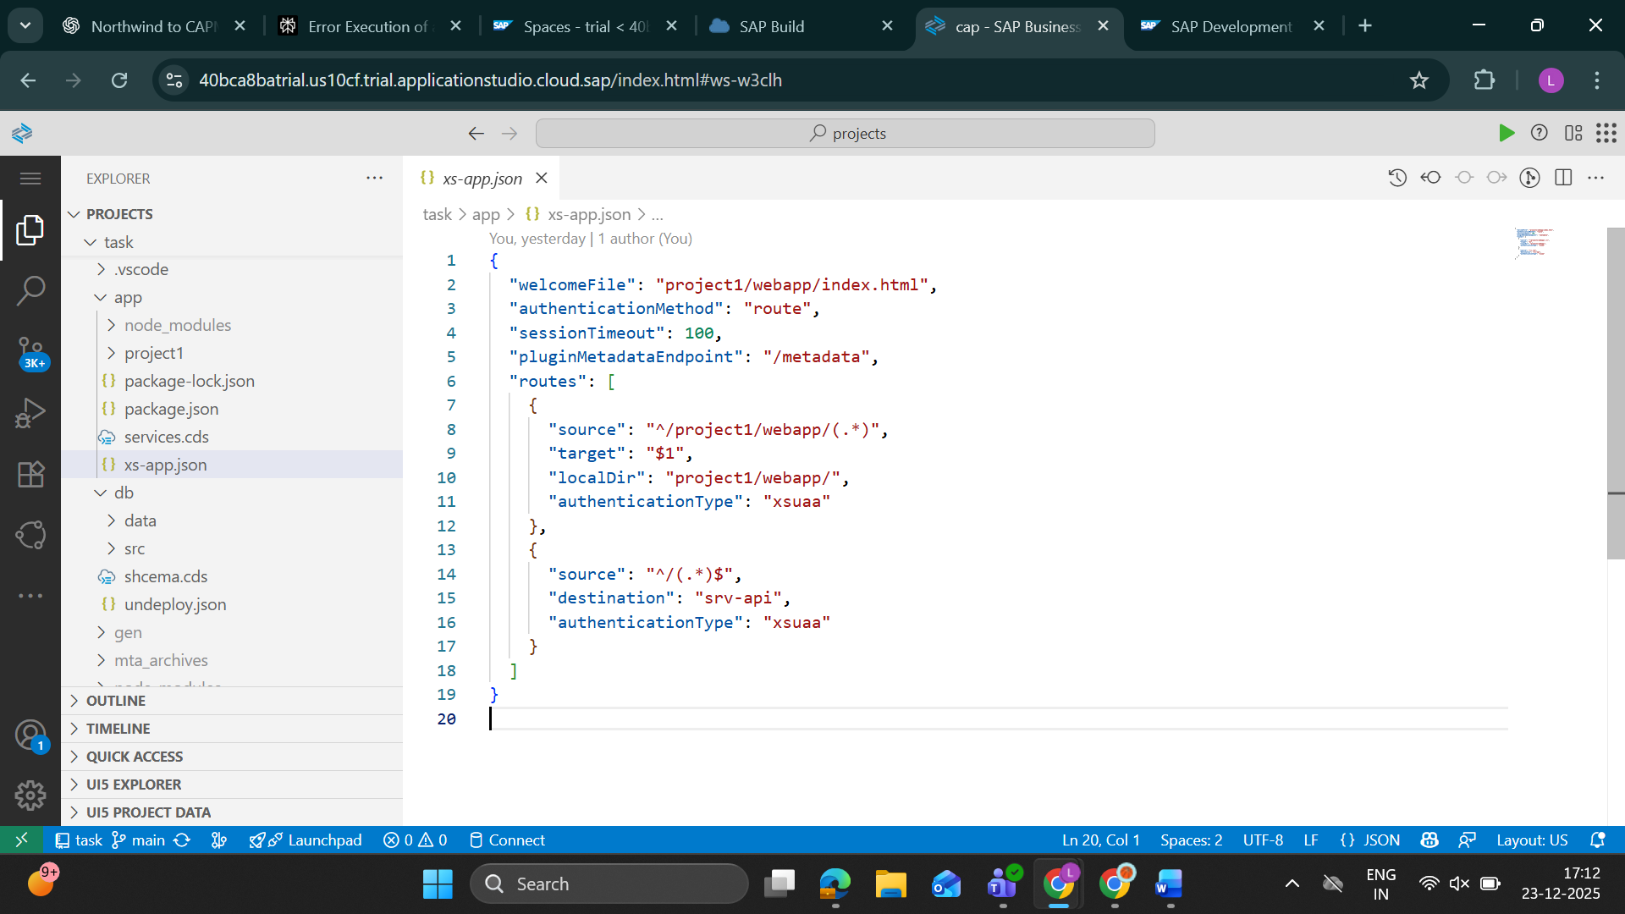

1. **ANNONTATIONS**

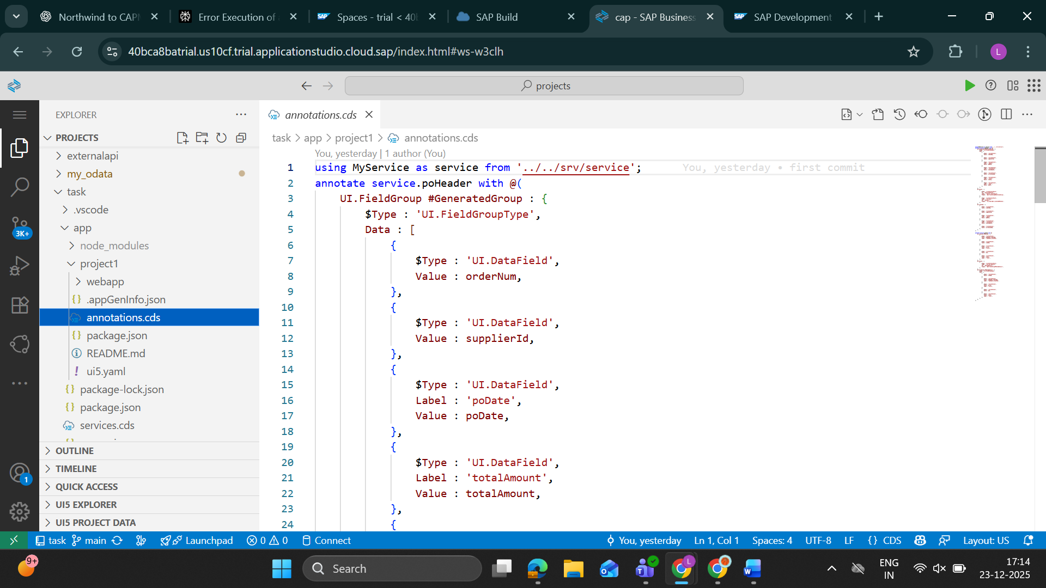

1. **MTA.YAML**

1. **MTA_ARCHIVES**

**OUTPUT**

**LIST PAGE**

**OBJECT PAGE**

**ITEM PAGE**

**CI/CD PIPELINE**



